**TUGAS PRAKTIKUM 5 PEMROGRAMAN 1**



NAMA : Muhamad Ary Utomo.P

NPM : 4513210026

TEKNIK INFORMATIKA 2013

FAKULTAS TEKNIK

UNIVERSITAS PANCASILA

1. Program Objek-01 (Manusia.java)

|  |
| --- |
| Source code |
| public class Manusia {  public String nama;  public static void main(String [] args) {  Manusia orang = new Manusia();  orang.setNama("Ary");  System.out.println("Namaku adalah = " + orang.getNama());  }    public void setNama(String namaku) {  this.nama = namaku;  }    public String getNama() {  return this.nama;  }  } |

* Screen shoot

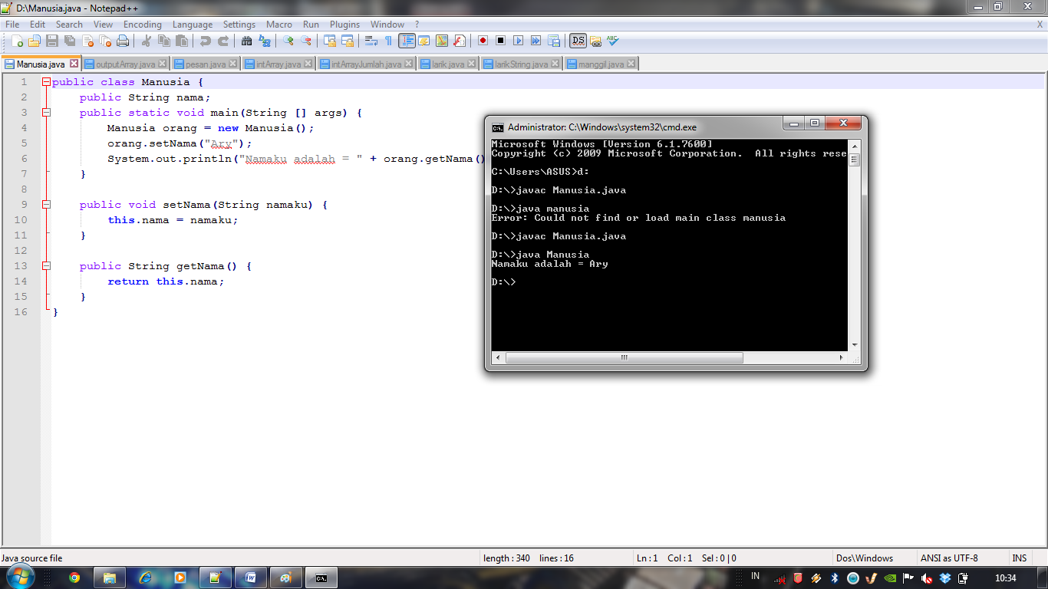

1. Program Objek-02 (Mahasiswa.java)

|  |
| --- |
| Source code |
| public class Mahasiswa {  intnilai;  public static void main(String [] args) {  Mahasiswa orang = new Mahasiswa();  orang.setNilai(98);  System.out.println("Nilaikuadalah = " + orang.getNilai());  }    public void setNilai(intnilaiku) {  this.nilai = nilaiku;  }    publicintgetNilai() {  returnthis.nilai;  }  } |

* Screen shoot

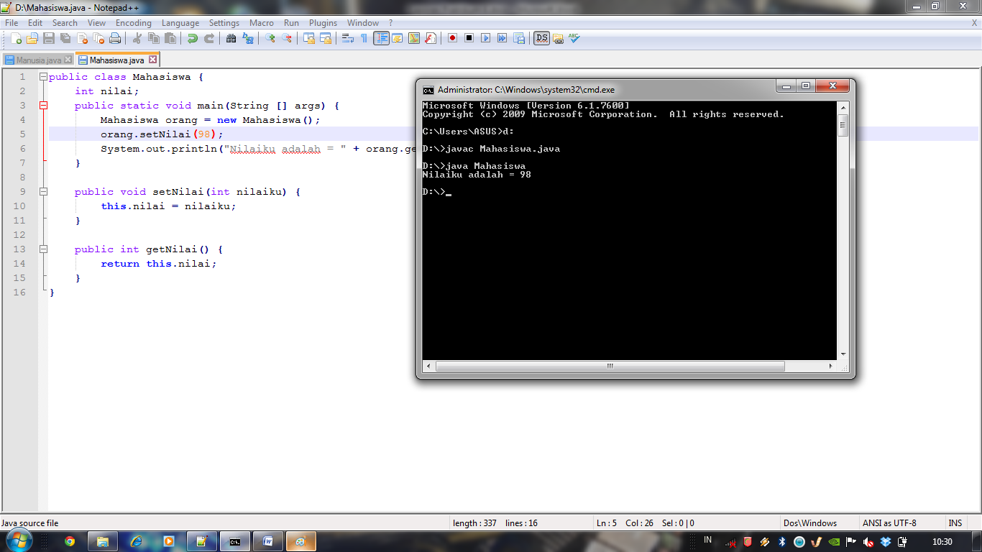

1. Class pesan (pesan.java)

|  |
| --- |
| Source Code |
| public class pesan{  public void tampil(){  System.out.println("Inidari method Tampilmilikkelaspesan");  }  } |

* Screen shoot

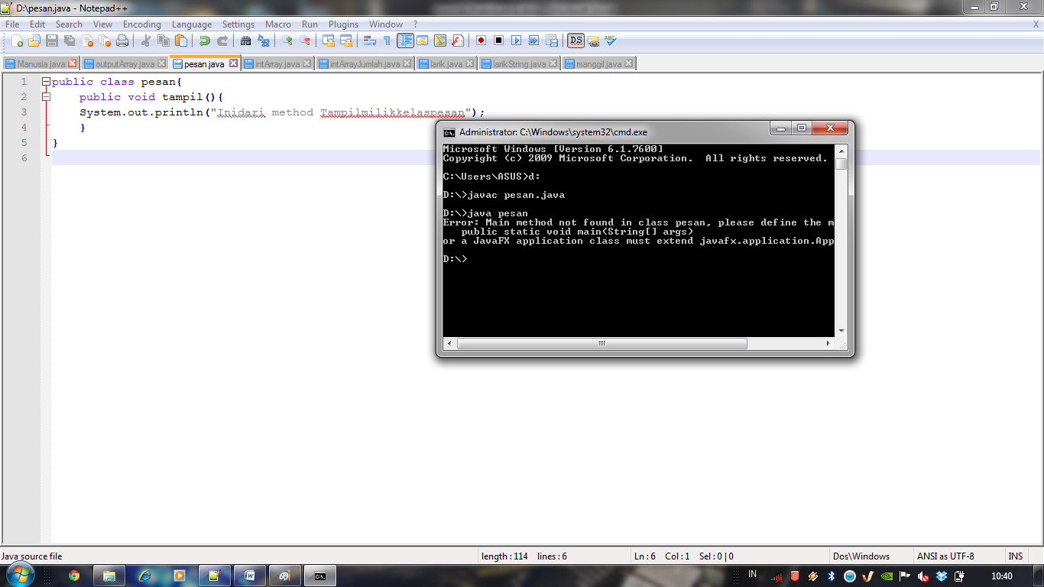

1. Class manggil🡪 manggil.java

|  |
| --- |
| Source code |
| public class manggil{  public static void main(String [] args){  pesanmuncul = new pesan();  muncul.tampil();  }  } |

* Screen shoot

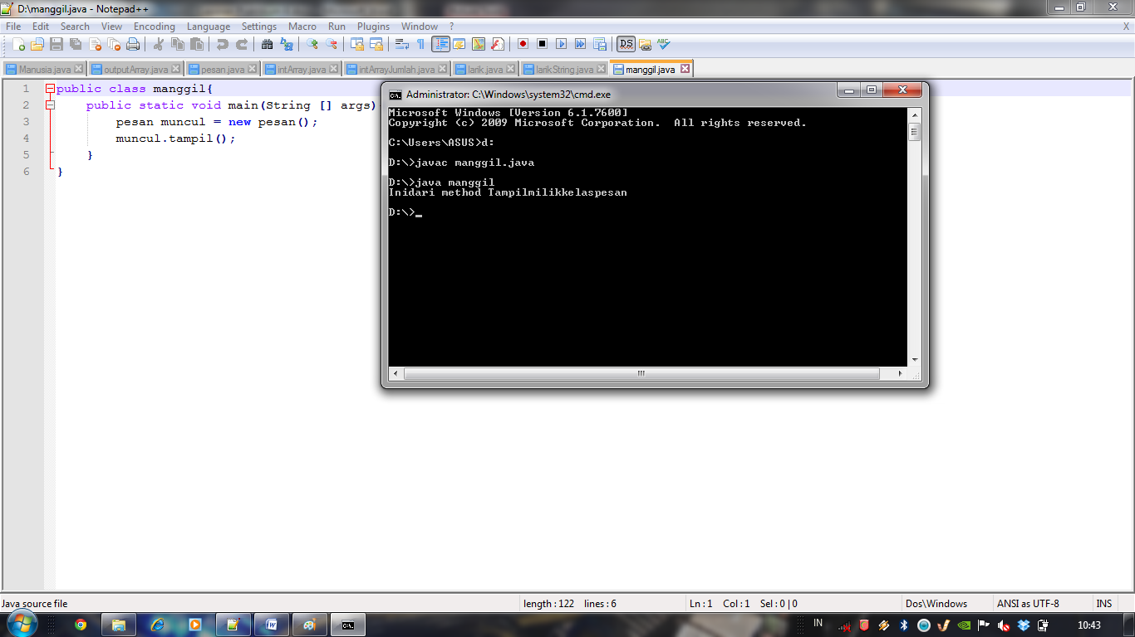

1. Program 5-05 (larik.java)

|  |
| --- |
| Source code |
| public class larik{  public static void main(String [] args){  int [] data = {4,9,7,3};  inti;  for(i=0;i<4;i++){  System.out.println(data[i]);  }    for(i=0;i<4;i++){  System.out.println("Elemenke-" + i + " adalah " + data[i]);  }  }  } |

* Screen Shoot

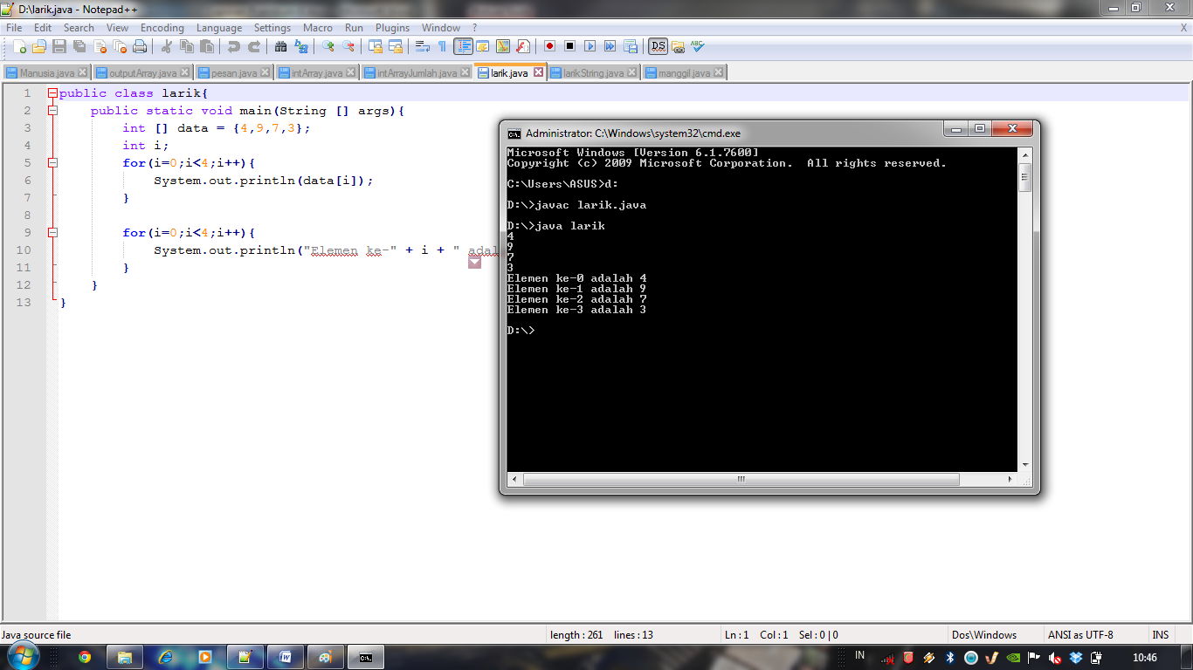

1. Program 5-06 🡪 larikString.java

|  |
| --- |
| Sourcecode |
| public class larikString{  public static void main(String [] args){  String [] dataString = {"Makan","Tidur","Mandi"};  inti;  for(i=0;i<3;i++){  System.out.println(dataString[i]);  }    for(i=0;i<3;i++){  System.out.println("HobiSaya = " + dataString[i]);  }  }  } |

* Screen shoot

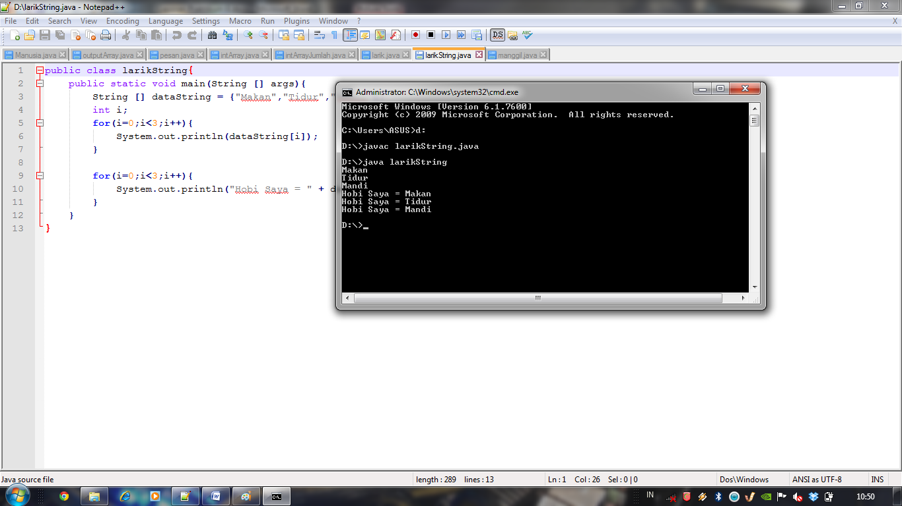

1. Program 5-07 🡪 intArray.java

|  |
| --- |
| Source code |
| importjava.util.Scanner;  public class intArray{  public static void main(String [] args){  intangka[] = new int[10];  inti;  intbanyak;  Scanner input = new Scanner(System.in);  System.out.print("MasukkanBanyakangka = ");  banyak = input.nextInt();    for(i=0;i<banyak;i++){  System.out.print("MasukkanAngka = ");  angka[i] = input.nextInt();  }  }  } |

* Screen shoot

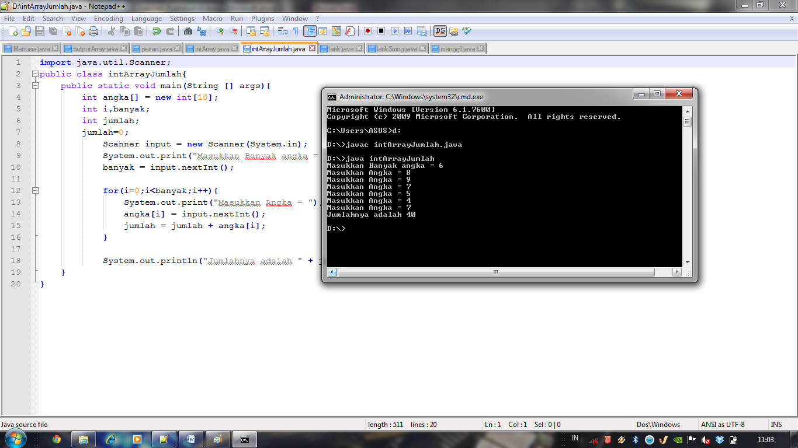

1. Program 5-08 ( intArrayInput.java)

|  |
| --- |
| Sourcecode |
| importjava.util.Scanner;  public class intArrayJumlah{  public static void main(String [] args){  intangka[] = new int[10];  inti,banyak;  intjumlah;  jumlah=0;  Scanner input = new Scanner(System.in);  System.out.print("MasukkanBanyakangka = ");  banyak = input.nextInt();    for(i=0;i<banyak;i++){  System.out.print("MasukkanAngka = ");  angka[i] = input.nextInt();  jumlah = jumlah + angka[i];  }    System.out.println("Jumlahnyaadalah " + jumlah);  }  } |

* Screen shoot

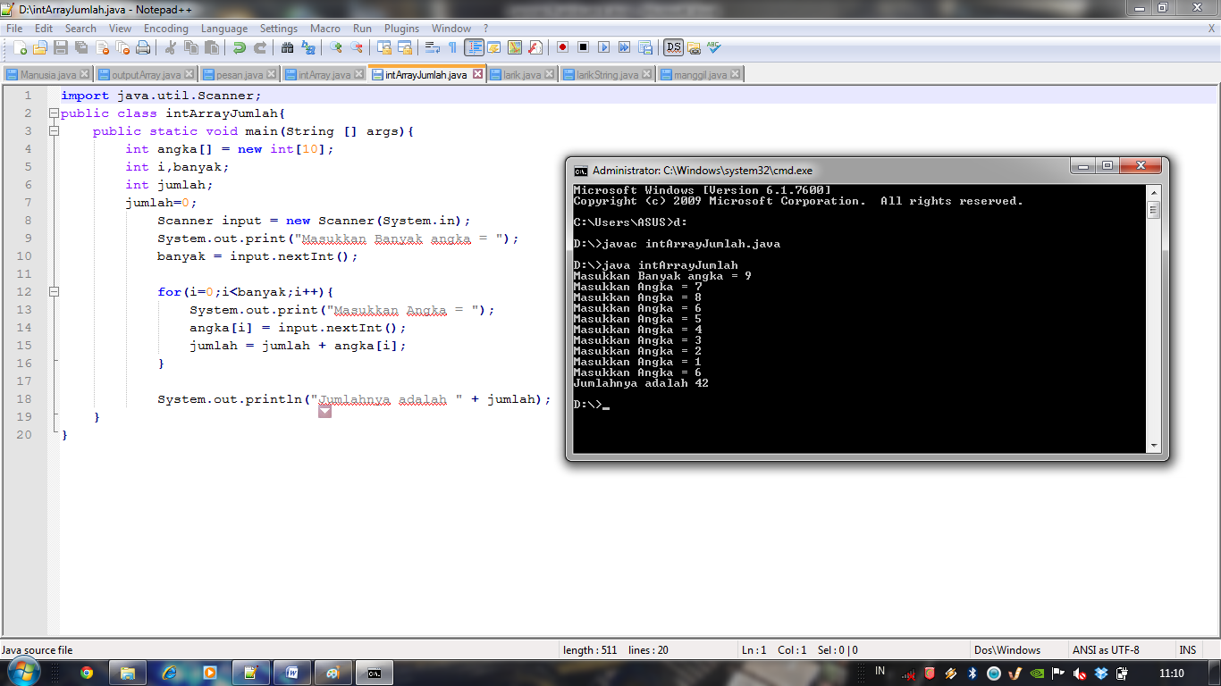

1. Program 5-09 (outputArray.java)

|  |
| --- |
| Sourcecode |
| importjava.util.Scanner;  public class outputArray{  public static void main(String [] args){  intangka[] = new int[10];  inti,banyak;  intjumlah;  jumlah=0;  Scanner input = new Scanner(System.in);  System.out.print("MasukkanBanyakangka = ");  banyak = input.nextInt();    for(i=0;i<banyak;i++){  System.out.print("MasukkanAngka = ");  angka[i] = input.nextInt();  jumlah = jumlah + angka[i];  }  System.out.println("Jumlahnyaadalah " + jumlah);  if(jumlah%2==0){  System.out.println("\nJumlahtermasukbilangangenap");  }  elseSystem.out.println("\nJumlahtermasukbilanganganjil");  }  } |

* Screen shoot

